Вывод композера,

ai@ubuntu20:~/wordpress$ sudo docker-compose ps

Name Command State Ports

------------------------------------------------------------------------

db docker-entrypoint.sh --def ... Up 3306/tcp, 33060/tcp

webserver nginx -g daemon off; Up 0.0.0.0:80->80/tcp

wordpress docker-entrypoint.sh php-fpm Up 9000/tcp

**Все поднялось, но база не пашет!!!**

захожу на хост, получаю это:

**Error establishing a database connection**

Похоже инсталятор wordpress не запускается из ошибки коннекта к базе.

Перенес пароли напрямую в конфиги композера из .env файла.

Не помогает. Не понимаю, где ошибка.

**Порты на хосте**

ai@ubuntu20:~$ nmap localhost

Starting Nmap 7.80 ( https://nmap.org ) at 2020-06-19 15:30 MSK

Nmap scan report for localhost (127.0.0.1)

Host is up (0.00020s latency).

Not shown: 996 closed ports

PORT STATE SERVICE

22/tcp open ssh

80/tcp open http

631/tcp open ipp

10000/tcp open snet-sensor-mgmt

**А разве не должны светится тут 3606 и 9000?????**

**Попробовал workbench**

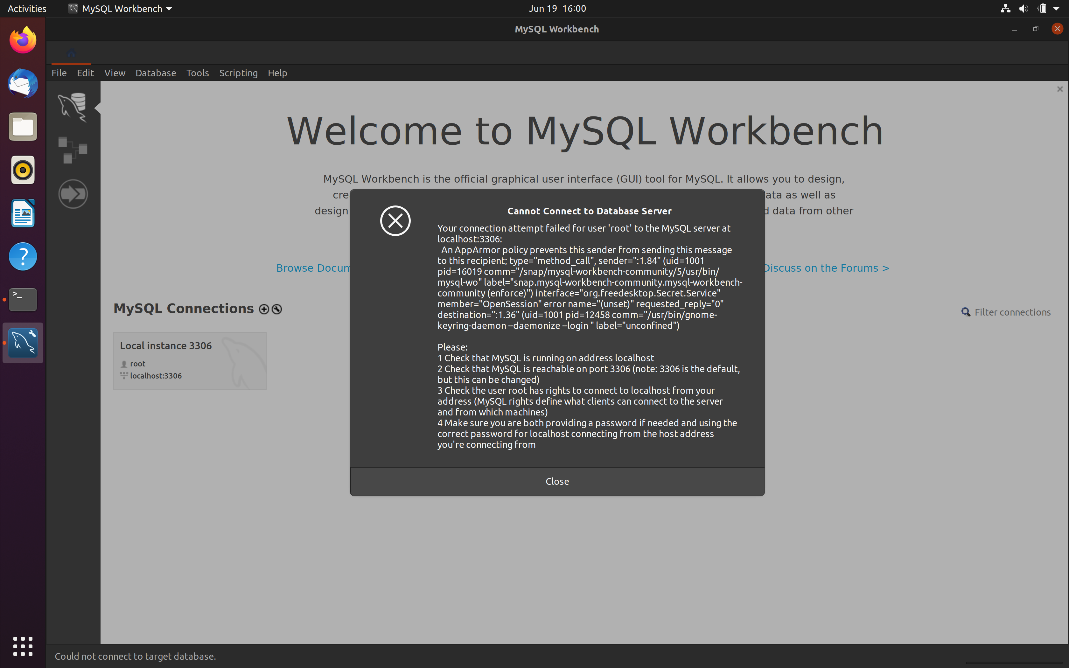



НАДО APP Armor править и для php wordpress nginx??????

**Запускал bash в контейнере db и пытал mysql**

**База есть**

ai@ubuntu20:~/wordpress/nginx-conf$ sudo docker exec -it 82761e7fa801 bash

[sudo] password for ai:

root@82761e7fa801:/#

root@82761e7fa801:/# mysql -u root

ERROR 1045 (28000): Access denied for user 'root'@'localhost' (using password: NO)

root@82761e7fa801:/# mysql -u root -p

Enter password:

Welcome to the MySQL monitor. Commands end with ; or \g.

Your MySQL connection id is 52

Server version: 8.0.20 MySQL Community Server - GPL

Copyright (c) 2000, 2020, Oracle and/or its affiliates. All rights reserved.

Oracle is a registered trademark of Oracle Corporation and/or its

affiliates. Other names may be trademarks of their respective

owners.

Type 'help;' or '\h' for help. Type '\c' to clear the current input statement.

mysql> show databases;

+--------------------+

| Database |

+--------------------+

| information_schema |

| mysql |

| performance_schema |

| sys |

| wordpress |

+--------------------+

5 rows in set (0.00 sec)

**Конфиг composer’a**

ai@ubuntu20:~/wordpress$ cat docker-compose.yml

version: '3'

services:

db:

image: mysql:8.0

container_name: db

restart: unless-stopped

environment:

- MYSQL_DATABASE=wordpress

- MYSQL_ROOT_PASSWORD=12345678(мой реальный пароль рута тут)

- MYSQL_USER=db

- MYSQL_PASSWORD=db

volumes:

- dbdata:/var/lib/mysql

command: '--default-authentication-plugin=mysql_native_password'

networks:

- app-network

wordpress:

depends_on:

- db

image: wordpress:5.1.1-fpm-alpine

container_name: wordpress

restart: unless-stopped

environment:

- WORDPRESS_DB_HOST=db:3306

- WORDPRESS_DB_USER=db

- WORDPRESS_DB_PASSWORD=db

- WORDPRESS_DB_NAME=wordpress

volumes:

- wordpress:/var/www/html

networks:

- app-network

webserver:

depends_on:

- wordpress

image: nginx:1.15.12-alpine

container_name: webserver

restart: unless-stopped

ports:

- "80:80"

volumes:

- wordpress:/var/www/html

- ./nginx-conf:/etc/nginx/conf.d

networks:

- app-network

volumes:

wordpress:

dbdata:

networks:

app-network:

driver: bridge

**Конфиг nginx**

i@ubuntu20:~/wordpress/nginx-conf$ cat nginx.conf

server {

listen 80;

listen [::]:80;

server_name hw8.ru www.hw8.ru;

index index.php index.html index.htm;

root /var/www/html;

location ~ /.well-known/acme-challenge {

allow all;

root /var/www/html;

}

location / {

try_files $uri $uri/ /index.php$is_args$args;

}

location ~ \.php$ {

try_files $uri =404;

fastcgi_split_path_info ^(.+\.php)(/.+)$;

fastcgi_pass wordpress:9000;

fastcgi_index index.php;

include fastcgi_params;

fastcgi_param SCRIPT_FILENAME $document_root$fastcgi_script_name;

fastcgi_param PATH_INFO $fastcgi_path_info;

}

location ~ /\.ht {

deny all;

}

location = /favicon.ico {

log_not_found off; access_log off;

}

location = /robots.txt {

log_not_found off; access_log off; allow all;

}

location ~* \.(css|gif|ico|jpeg|jpg|js|png)$ {

expires max;

log_not_found off;

}

}